Kunal Sachdeva

Submitted To: Mr. Nilesh Sharma 19115045

Submission Deadline:12-04-2021 SE Term Paper

***Evolutionary Process Models in Software Engineering***

**Abstract**

Software development life cycle models play a vital role in developing a software application. This term paper deals with such advanced models which are the evolutionary models namely: incremental model, and spiral model. Both these models have their own advantages and disadvantages as well. The main objective of this research paper is to represent the two evolutionary models features and limitations.

**Introduction:**

Evolutionary model is a combination of Iterative and Incremental model of software development life cycle. Delivering your system in a big bang release, delivering it in incremental process over time is the action done in this model. Some initial requirements and architecture envisioning need to be done.

The evolutionary model is the model of software engineering. In the evolutionary model, all the work is done during the development phase. In this model, all work divided into small chunks or modules. For example, the Waterfall model in which all the users are able to get access to the product at the end of each cycle. This model is a combination of incremental and iterative models.

It is better for software products that have their feature sets redefined during development because of user feedback and other factors. The Evolutionary development model divides the development cycle into smaller, incremental waterfall models in which users are able to get access to the product at the end of each cycle.

Feedback is provided by the users on the product for the planning stage of the next cycle and the development team responds, often by changing the product, plan or process. Therefore, the software product evolves with time.

It is a very suitable model because of user feedback and other factors that make the model very suitable for the development of complete Software. The user feedback is very helpful for the development of the next stage because after the completion of one stage we get the feedback to the user, the user feedback is very essential for the development of the next phase.

All the models have the disadvantage that the duration of time from start of the project to the delivery time of a solution is very high. Evolutionary model solves this problem in a different approach.

In the evolutionary model, all work divided into smaller chunks. These chunks present to the customer one by one. The confidence of the customer increased. This model also allows for changing requirements as well as all development done into different pieces and maintains all the work as a chunk.

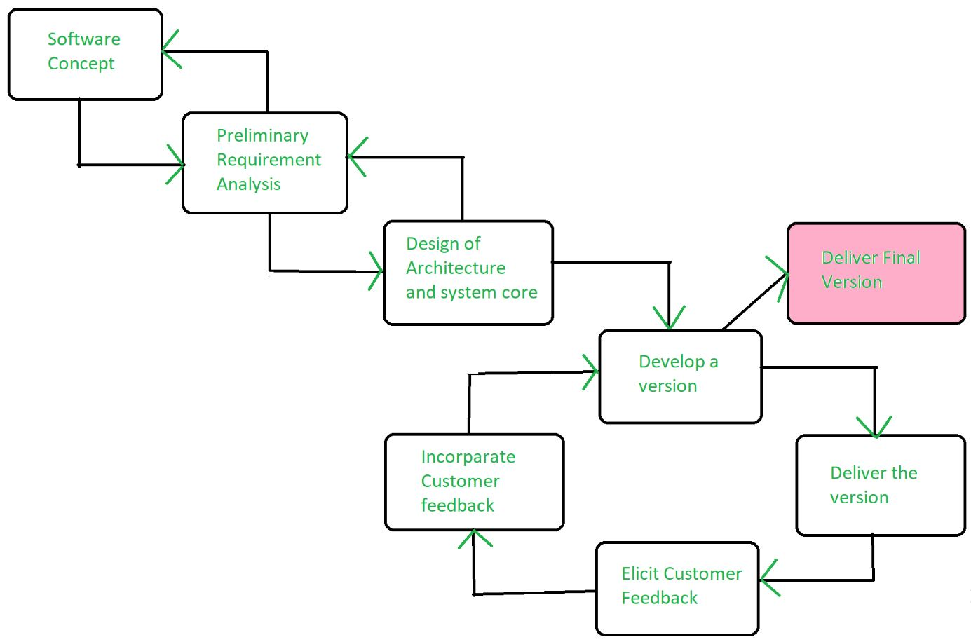

They are basically iterative. Once the requirements are analysed, they pass through a series of iterations till the complete software is developed. The evolutionary models mainly support the programmer to develop the complete version of a software. After each release, based on the review given by the reviewers, further iterations are performed. It’s mostly employed to make the reliable version of the software. It involves more user interaction in every iteration, and thereby increasing reliability.

**Advantages of Evolutionary Model:**

There are many advantages of evolutionary model, some main advantages are mentioned below;

* The big advantage of the evolutionary model is that the user has checked every stage during the development and it is helpful in achieving customer confidence.
* There are fewer chances of errors because all the modules are well seen.
* It helps to reduce the risk of software projects.
* It also reduces the cost of development.
* Minimize serious problems during testing.

**Disadvantages of Evolutionary Model:**

There are many dis-advantages of evolutionary model, some main advantages are mentioned below:

* The delivery of full software can be late due to different changes by customers during development.
* It is difficult to divide the problem into several parts, that would be acceptable to the customer which can be incrementally implemented and delivered.

**Application of Evolutionary Model:**

Evolutionary model is useful in many cases. Two most important cases are mentioned below:

* It is very useful in a large project where you can easily find a module for step-by-step implementation. The evolutionary model is used when the users need to start using the many features instead of waiting for the complete software.
* The evolutionary model is also very useful in object-oriented software development because all the development is divided into different units.

Following are the evolutionary process models.

1. The prototyping model
2. The spiral model
3. Concurrent development model

**1. The Prototyping model**

* Prototype is defined as first or preliminary form using which other forms are copied or derived.
* Prototype model is a set of general objectives for software.
* It does not identify the requirements like detailed input, output.
* It is software working model of limited functionality.
* In this model, working programs are quickly produced.

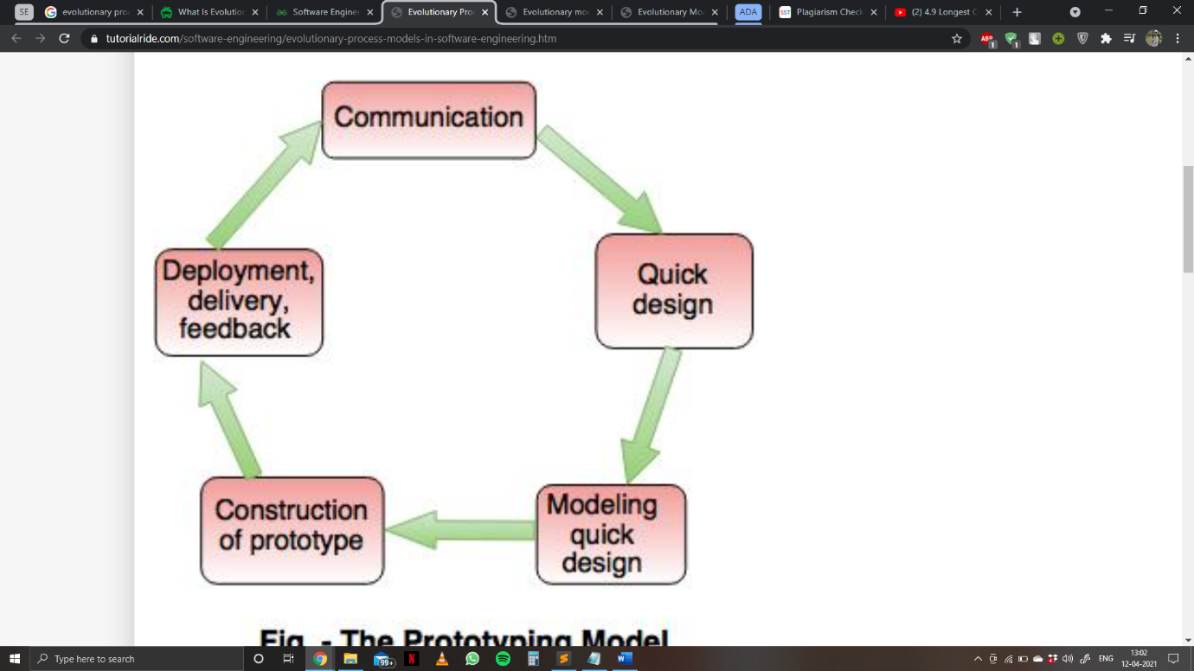

*The Prototyping model*

The different phases of Prototyping model are:

*1. Communication*

In this phase, developer and customer meet and discuss the overall objectives of the software.

*2. Quick design*

* Quick design is implemented when requirements are known.
* It includes only the important aspects like input and output format of the software.
* It focuses on those aspects which are visible to the user rather than the detailed plan.
* It helps to construct a prototype.

*3. Modelling quick design*

* This phase gives the clear idea about the development of software because the software is now built.
* It allows the developer to better understand the exact requirements.

*4. Construction of prototype*

The prototype is evaluated by the customer itself.

*5. Deployment, delivery, feedback*

* If the user is not satisfied with current prototype then it refines according to the requirements of the user.
* The process of refining the prototype is repeated until all the requirements of users are met.
* When the users are satisfied with the developed prototype then the system is developed on the basis of final prototype.

Advantages of Prototyping Model:

* Prototype model need not know the detailed input, output, processes, adaptability of operating system and full machine interaction.
* In the development process of this model users are actively involved.
* The development process is the best platform to understand the system by the user.
* Errors are detected much earlier.
* Gives quick user feedback for better solutions.
* It identifies the missing functionality easily. It also identifies the confusing or difficult functions.

Disadvantages of Prototyping Model:

* The client involvement is more and it is not always considered by the developer.
* It is a slow process because it takes more time for development.
* Many changes can disturb the rhythm of the development team.
* It is a thrown away prototype when the users are confused with it.

**2. The Spiral model**

* Spiral model is a risk driven process model.
* It is used for generating the software projects.
* In spiral model, an alternate solution is provided if the risk is found in the risk analysis, then alternate solutions are suggested and implemented.
* It is a combination of prototype and sequential model or waterfall model.
* In one iteration all activities are done, for large project's the output is small.

The framework activities of the spiral model are as shown in the following figure.

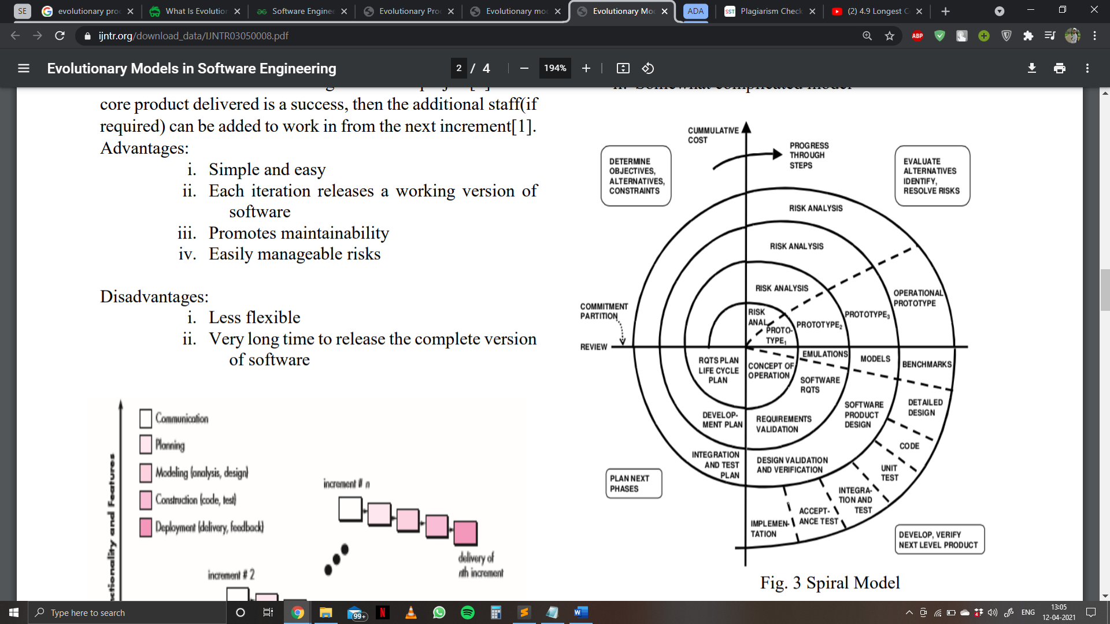

*The Spiral Model*

Advantages of Spiral Model:

* It reduces high amount of risk.
* It is good for large and critical projects.
* It gives strong approval and documentation control.
* In spiral model, the software is produced early in the life cycle process.

Disadvantages of Spiral Model:

* It can be costly to develop a software model.
* It is not used for small projects.

**3. The concurrent development model**

* The concurrent development model is called as concurrent model.
* The communication activity has completed in the first iteration and exits in the awaiting changes state.
* The modelling activity completed its initial communication and then go to the underdevelopment state.
* If the customer specifies the change in the requirement, then the modelling activity moves from the under-development state into the awaiting change state.
* The concurrent process model activities moving from one state to another state.

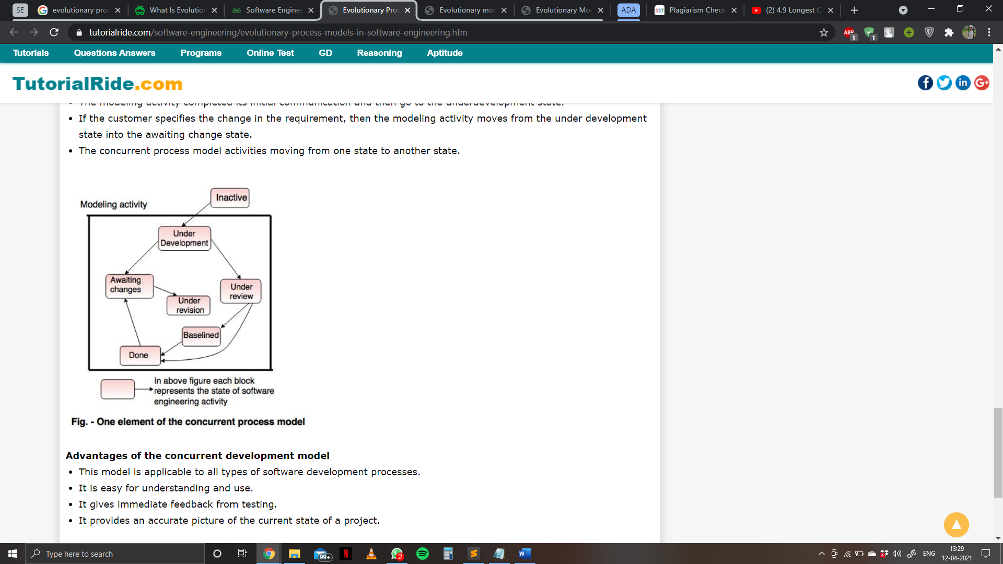

*One element of the concurrent process model*

Advantages of the concurrent development model:

* This model is applicable to all types of software development processes.
* It is easy for understanding and use.
* It gives immediate feedback from testing.
* It provides an accurate picture of the current state of a project.

Disadvantages of the concurrent development model:

* It needs better communication between the team members. This may not be achieved all the time.
* It requires to remember the status of the different activities.

**References**

* [**tutorialride.com**](tutorialride.com)
* [**geeksforgeeks.org**](geeksforgeeks.org)
* [**ijntr.org**](ijntr.org)